**Problem-1**

**Student Name: Milan Sharma UID: 23MAI10003**

**Branch: ME – CSE - AIML Section/Group: MAI– 1 (A)**

**Semester: 1st Date of Performance:**

**Subject Name: Python Programming Subject Code: 23 CSH 623**

1. **Aim of the Experiment :**

In a coding contest, there are prizes for the top rankers. The prize scheme is as follows:

* Top 1010 participants receive rupees *X* each.
* Participants with rank 1111 to 100100 (both inclusive) receive rupees *Y* each.

Find the total prize money over all the contestants.

1. **Objective of the Experiment :**

Objective of the Experiment is to calculatetotal prize money over all the contestants.

1. **Algorithm/ Steps for Experiment :**

Step 1: Take input from the user in integer.

Step 2: Run for loop in range of given user input.

Step 3: Takes two integer inputs from the user and assigns them to the variables x and y.

Step 4: The map() function takes a function (in this case, the int function).

Step 5: The map() function applies it to each part of the enumerable returned by the split() function.

1. **Code for Experiment :**

# cook your dish here

n=int(input())

for i in range(n):

x,y=map(int,input().split())

print(x*10+90*y)

1. **Result/Output :**

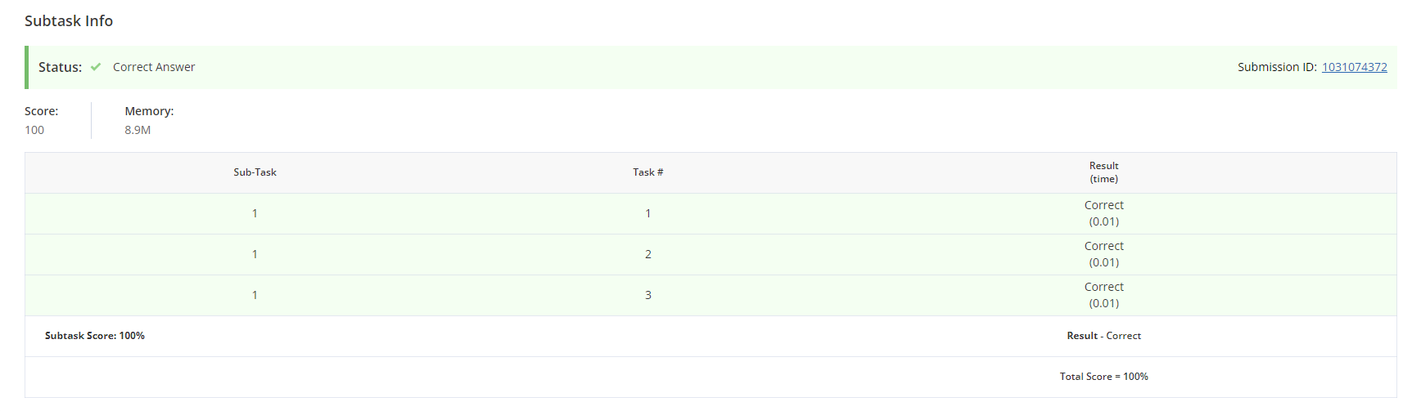

**Learning outcomes (What I have learnt):**

1. Learnt about the python programming.
2. Learnt how to take input from the user in integer.
3. Learnt about map() function.
4. Learnt about split() function.